Design Documentation
Citypoint hire bookings
Tochukwu Chukwudolue
2026

Creating and setting up the project
The project was created using ASP.NET Core-Web App
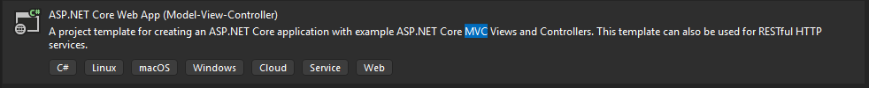
This template allows us to take use of Models, Views and Controllers which are utilised when creating both the front end and back end of a web application.
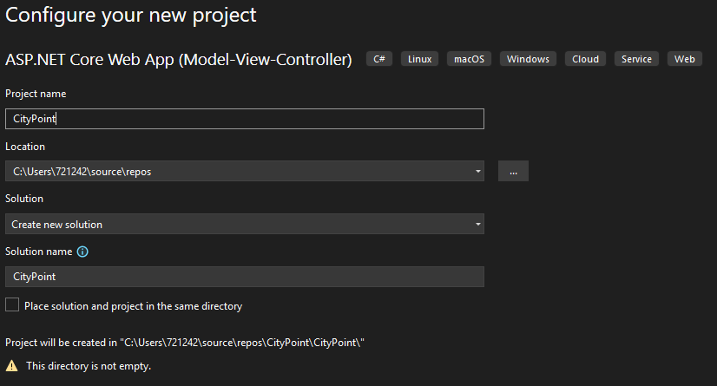
We name the project City Point as it is an appropriate for the application. We selected the .NET 9.0 Framework since it allows for better performance, new features, scalability and better optimisation.
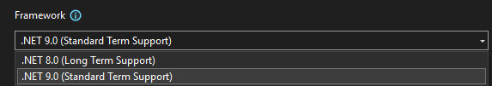
We select Individual accounts as this creates a Register and Log-In template which we can utilise for our web application. It creates the user database for us and all the functionality, being able to edit it and customise it to our needs.
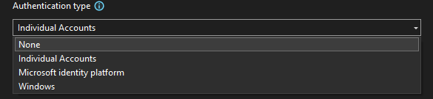

We then tap on create. This builds the template for us to work on. Everything appears as expected but three additional packages were installed which allowed for some extra functionality. They were;
- Microsoft.VisualStudio.Web.CodeGeneration.Design
- Microsoft.EntityFrameworkCore.Design
- Microsoft.Entity.FrameworkCore.SqlServer
The solution comes with pre-installed folders which would house the Models, Views and Controllers which would be built for the solution.
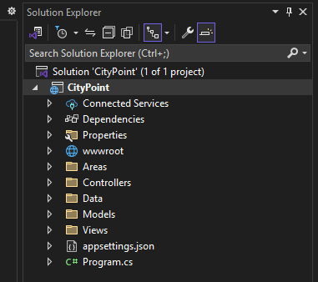
Before we click on the run button, we change the format from HTTPS to HTTP. After which, we can check whether there are any build errors in the project
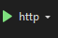
The Website appears to be functional with four buttons (Home and Privacy), alongside the Register and Log-In.
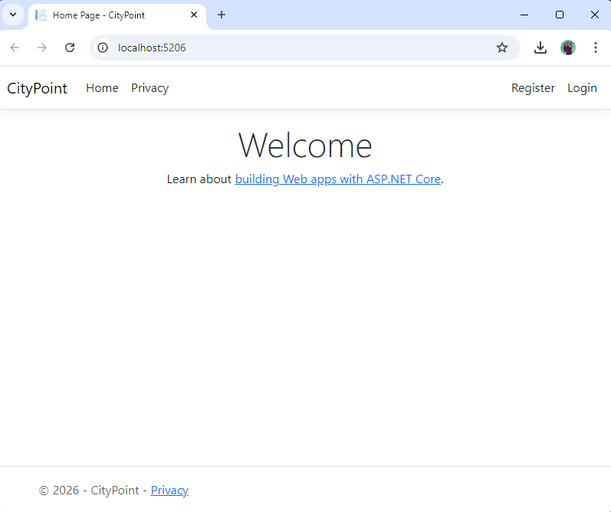
Both the Register and Log-In buttons work and it redirects you to their respective pages. They have the typical features of any Sign up/ Sign in page.
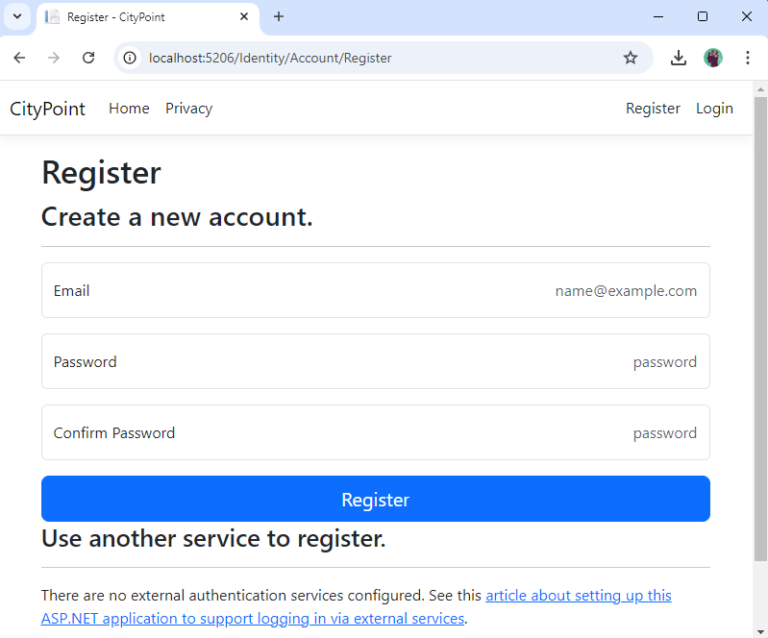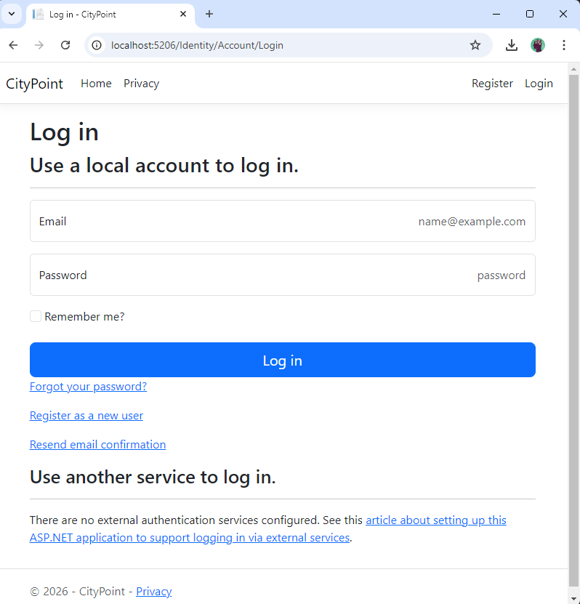

However, when we attempt to Register we get a migration error, and the system does not save our information in it’s database, This issue can be fixed easily by adding a Migration and Updating our Database which would be done in due time.
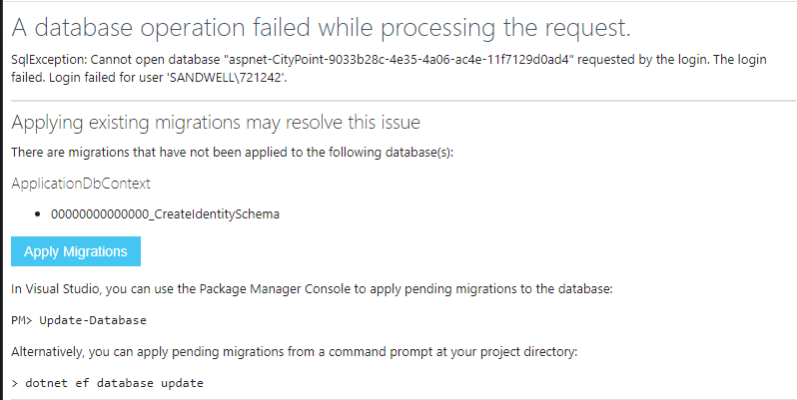

Creating all required Models
